**Overview**

The goal of this thesis is to develop a virtual user simulator that will generate robust dialog data to support goal-oriented task completion dialog research. I will be re-engineering the TC-Bot1 described in Li, Lipton, et. all2 . TC-Bot was written as a research proof-of-concept in order demonstrate the generation of human speech utterances and training of dialog systems in the context of booking movie tickets. User simulators are utilized by the dialog research community as a cost-efficient way to train their dialog systems using reinforcement learning. However, there exists no standardized user simulator tool. Researchers must develop and build from scratch user simulators for each new domain and dialog system they build.

The goal is of this thesis is to develop a modularized and production grade user simulator, which will provide a set of common APIs to train dialog agents. I plan to leverage good software engineering principles so that underlying framework can support expansion into other task completion domains like hotel book or flight reservations.

To demonstrate good software design principles, I aim to highlight the following principles:

* Modularity
  + The user simulator will be broken up into modules to address specific functionality such as user agenda management, natural language understanding, and natural language
* Principle of Least Knowledge
  + Explicitly this will be demonstrated with a set of API calls that will allow a research interface the user simulator with their dialog system.
* Generality
  + The system will support retargeting to new task completion dialog domains. For this thesis I will support the TC-Bot’s movie booking domain and expand to restaurant search.

**Project Details**

Underlying the dialog simulator will be a framework that contains the following components:

* **User Simulator**: An agenda based user modelling component that generates natural language speech utterances to simulate what an actual human would say in the context of task-completion dialog.
* **Dialog Agent API**: A set of methods to allow a researcher to provide an agent(s) that simulate how the system / dialog agent would respond to user input
* **Dialog Manager:** a coordinator component that tracks the current state of the dialog and facilitates the conversation between between the user simulator and dialog agent/system. Add the end of the simulated conversation, the manager will evaluate and score the conversion.

Below is visual representation of the user simulator framework described in Li, Lipton, et. all.

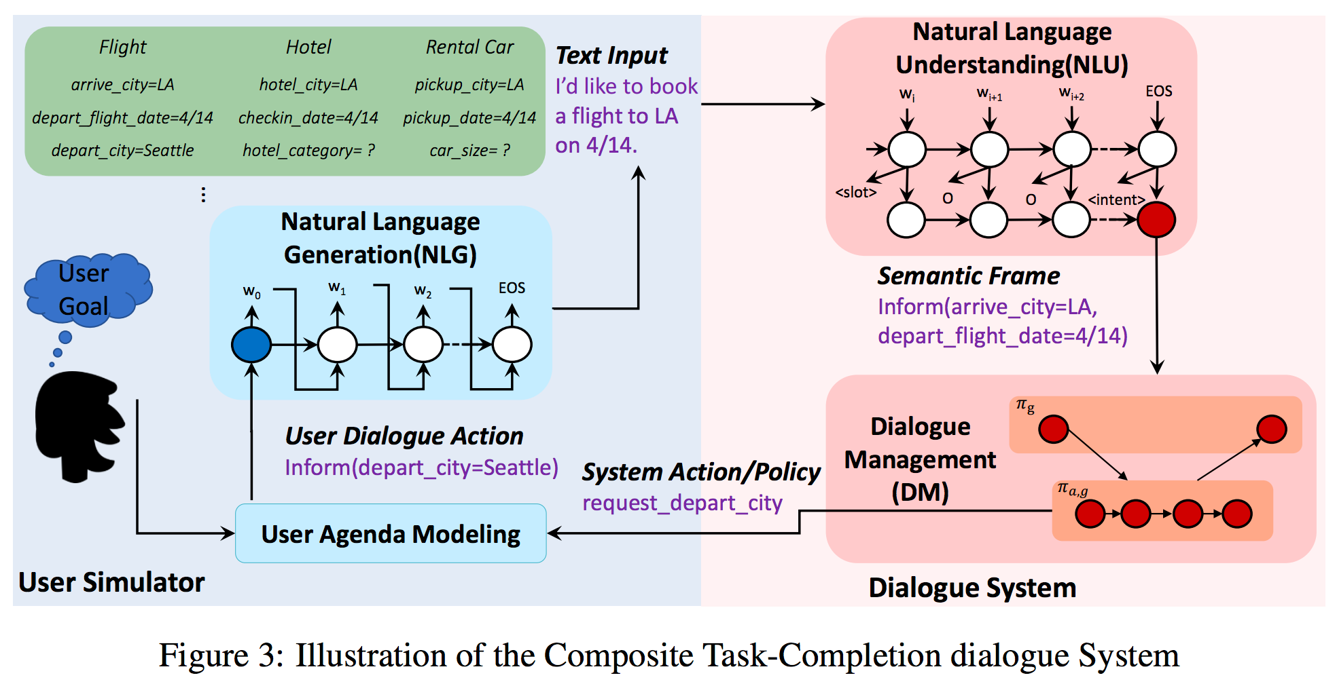

**Thesis Timeline**

The goal is to finish this thesis by May 2018.

**Key Milestones**

**2017**

**September:** Manual simulator scaffolding with user agenda generation.

**October - November:** Implement a rule based user simulator

**December:** Simulator supports NLG with LSTM decoder module

**2018**

**January:** Demonstrate retargeting and support restaurant domain **February - March:** UI and reporting/metrics visualization **April- May:** Thesis Finalized and submitted **References**

[1] https://github.com/MiuLab/TC-Bot

[2] Li, X., Lipton, Z., Dhingra, B., Li, L., Gao, J., & Chen, Y. (2017). *A User Simulator for Task-Completion Dialogues*. *Arxiv.org*. Retrieved 21 May 2017, from <https://arxiv.org/abs/1612.05688>